EXP 5 MIMO System Simulation with BER Analysis
Objective:
- To implement 2×2 and 4×4 MIMO to study spatial multiplexing and improve link reliability.
- To analyze throughput, spectral efficiency, and BER to evaluate overall downlink performance.

Theory:

1. LTE (Long Term Evolution)
It a 4G wireless communication standard that provides high-speed data transmission using advanced digital modulation and coding techniques.

2. OFDMA (Orthogonal Frequency Division Multiple Access)
It divides the bandwidth into many orthogonal subcarriers, allowing simultaneous data transmission to multiple users with reduced interference

3. MIMO (Multiple Input Multiple Output)
MIMO uses multiple transmit and receive antennas to increase data rates through spatial multiplexing and improve reliability through spatial diversity.

4. LTE Downlink
The LTE downlink combines OFDMA and MIMO to achieve high spectral efficiency, robust performance, and enhanced throughput in real-world wireless environments.

5. Effect of parameter metrics
Performance metrics such as Bit Error Rate (BER), throughput, and spectral efficiency help evaluate the effectiveness and reliability of LTE downlink communication systems.

Procedure:
- Define system parameters: number of subcarriers (Nsubcarriers), modulation order (modOrder), MIMO streams (MIMOStreams).
- Calculate bits per symbol and throughput per user.
3. Generate random bitstream for one user.
4. Map bits to 16-QAM symbols.
5. Assign symbols to subcarriers and generate OFDM signal using IFFT.
6. Plot the OFDM signal spectrum using FFT.
7. Plot the time-domain OFDM signal (real part).
8. Plot the 16-QAM constellation diagram for transmitted symbols.
9. Display calculated parameters: number of subcarriers, throughput per user, total throughput with MIMO.

Code:

clear; clc; close all;

%% PARAMETERS
numBits = 1e5; SNRdB = 0:2:20; bps = 2;

%% STUDENT INPUT: CHANGE MIMO ORDER
Nt = input('Transmit antennas Nt: ');
Nr = input('Receive antennas Nr: ');

%% QPSK SYMBOLS
bits = randi([0 1], numBits,1);
bits_reshape = reshape(bits, bps, []).';
symbols = (2*bits_reshape(:,1)-1) + 1j*(2*bits_reshape(:,2)-1);
symbols = symbols/sqrt(2);
numSym = length(symbols);

%% SIMULATION
BER = zeros(1,length(SNRdB));
for s = 1:length(SNRdB)
snr = 10^(SNRdB(s)/10);
noiseVar = 1/snr;

% Reshape symbols for MIMO
sym_tx = reshape(symbols, Nt, []).';

% Channel & noise
H = (randn(Nr,Nt,size(sym_tx,1))+1j*randn(Nr,Nt,size(sym_tx,1)))/sqrt(2);
n = sqrt(noiseVar/2)*(randn(Nr,size(H,3))+1j*randn(Nr,size(H,3)));

% Receive & Zero-Forcing
y = zeros(Nr,size(H,3));
x_hat = zeros(Nt,size(H,3));
for k=1:size(H,3)
y(:,k) = H(:,:,k)*sym_tx(k,:).' + n(:,k);
x_hat(:,k) = pinv(H(:,:,k))*y(:,k);
end

% Demodulate
x_hat_vec = x_hat.'; x_hat_vec = x_hat_vec(:);
bits_rx = zeros(numBits,1);
bits_rx(1:2:end) = real(x_hat_vec)>0; bits_rx(2:2:end) = imag(x_hat_vec)>0;
BER(s) = sum(bits~=bits_rx)/numBits;
end

%% PLOT
figure; semilogy(SNRdB, BER,'-o','LineWidth',2);
grid on; xlabel('SNR (dB)'); ylabel('BER');
title(sprintf('%dx%d MIMO BER vs SNR (QPSK, ZF)', Nt, Nr));

PSEUDO CODE :

BEGIN

1. Initialize system parameters:
Set Nt, Nr, modulation order M, detector type (ZF/MMSE)
Set OFDM parameters: Nfft, Nused, CP length, subcarrier spacing
Compute sampling frequency and OFDM symbol duration
Compute bitsPerSymbol = log2(M)
Set number of OFDM symbols and SNR range
Set number of spatial streams = Nt

2. Initialize result arrays:
BER[], Throughput[], SpectEff[]

3. FOR each SNR value:
Set noise variance based on SNR
Initialize totalErrorBits = 0, totalBits = 0, totalSuccessBits = 0

FOR each OFDM symbol:

a. TRANSMITTER:
FOR each transmit stream:
Generate random bits
Map bits → QAM symbols
Store symbols in txSymbols(stream, subcarriers)

b. CHANNEL (per subcarrier):
FOR each subcarrier:
Generate Rayleigh channel matrix H
Extract transmitted symbol vector s
Generate noise vector n
Compute received vector y = H*s + n
Store y and H

c. RECEIVER DETECTION:
FOR each subcarrier:
Retrieve H and y
IF detector = ZF:
Compute W = pseudo-inverse(H)
ELSE (MMSE):
Compute W = (H'H + noiseVar*I)^(-1) * H'
Estimate symbols s_hat = W * y
Store s_hat

d. DEMODULATION AND ERROR COUNT:
Convert all estimated symbols → bits
Compare with transmitted bits
Count error bits
Update totalErrorBits, totalBits, totalSuccessBits

END FOR OFDM symbols

Compute BER = totalErrorBits / totalBits
Compute avgSuccessBits = totalSuccessBits / numOFDMsymbols
Compute Throughput = avgSuccessBits / OFDMsymbolDuration
Compute SpectEff = Throughput / bandwidth

Store results in BER[], Throughput[], SpectEff[]

END FOR SNR values

4. Plot:
BER vs SNR
Throughput vs SNR
Spectral Efficiency vs SNR

5. Display summary table of all metrics

OUTPUT:

4 x 4 MIMO
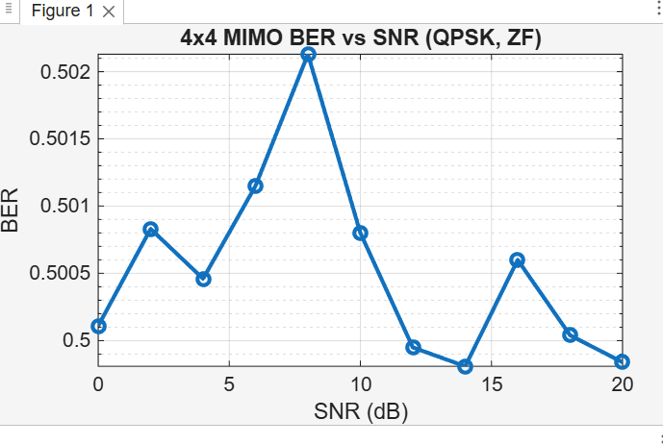
2 x 2 MIMO
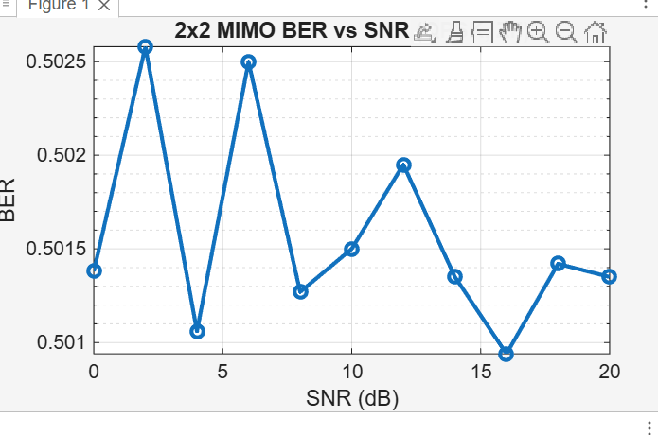
FLOW CHART :
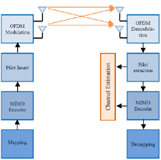
CONSOLE OUTPUT:
4 x 4 MIMO

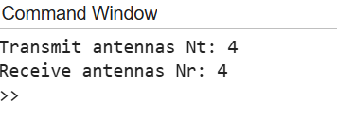
2 x 2 MIMO
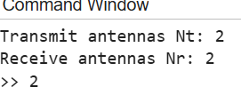

Conclusion:

- The throughput per user and total throughput increased with the number of MIMO streams.
- The OFDM spectrum, time-domain signal, and 16-QAM constellation provided insights into the LTE physical layer.
- This minimal simulation can be extended to multiple users, higher-order MIMO, and larger OFDM symbols for more realistic LTE system analysis.

